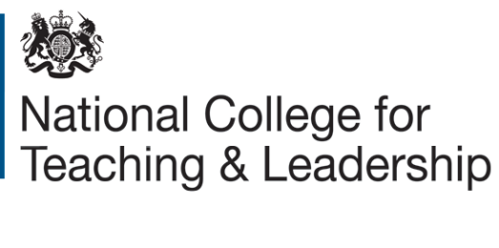
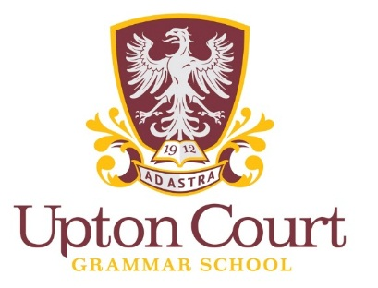
Do you have non subject specialist teaching Maths or Physics?
Do you want to create capacity to teach Maths and Physics by developing your staff?
Teacher Subject Specialism Training (TSST) in Maths/Physics
Free training based at Upton Court Grammar School during the 2017-18 academic year

TeachSlough is keen to involve schools in our TSST programme and work with them to enhance the subject knowledge of teachers. This programme is designed to address the national shortage of Maths/Physics teachers by upskilling existing teachers from different subjects who are currently teaching Maths or Physics.

This programme adopts a blended learning approach whereby delegates will receive pedagogical input during their ‘in school’ sessions, observations and coaching.

Programme 2017/18 - please register your interest for your school.

School Name:
CPL Lead:
Subject Offered | Yes | No | Number of places | Participant (s) Name(s)/Email(s)
Science
Maths

If you would like more information or to register an interest in this programme please contact Ravinder Ghei on rvg@uptoncourtgrammar.org.uk by 7th December 2017. Further details can be found here: https://www.gov.uk/guidance/teacher-subject-specialism-training-courses

